**II.2314 / II.2414**

**Advanced Databases and Big Data**

**Lab 1 & 2**

**GUO Xiaofan**

CONTENT

**Lab 1** 2

**Exercice 1: DDL queries** 2

**1. Copy** 2

**2. E/R diagram:** 3

**3. First integrity Constraint:** 3

**4. Second integrity Constraint** 4

**5. Third integrity Constraint on Delete** 4

**6. Explain Errors for Integrity Constraint** 6

**7. Define a sequence** 8

**8. Use Sequence:** 9

**Exercise 2: DML queries Answer the following queries using SQL.** 9

**1.** **List the content of all tables to see the attributes names.** 9

**2.** **Select employees whose commission is higher than their salary.** 10

**3.** **Select employees earning between 1200 and 2400 (earning is sal + commision)** 10

**4.** **Select employees who are CLERK or ANALYST** 11

**5.** **Select employees whose name begins by M.** 11

**6.** **Select employees whose name includes a L in second position.** 12

**7.** **Select employees who are MANAGER or CLERK in the department 10 and whose salary is greater than 1500.** 12

**8.** **Select employees whose commission is NULL** 13

**9.** **Select employees by ascending order (by hiredate)** 13

**10.** **Select employees ordered by job, and for each job, by decreasing salary** 14

**11.** **Select departments without employees** 14

**12.** **List employees indicating for each the name of his/her manager** 15

**13.** **List employees earning more than JONES** 16

**14.** **List employees displaying in the same column salary and commission** 16

**15.** **List department numbers which are both in table EMP and in table DEPT** 17

**16.** **List employees working in CHICAGO and having the same job than JONES** 17

**17.** **List employees who don't work in the same department than their manager** 18

**18.** **List employees working in a department having at least one CLERK** 18

**19.** **List employees of department 10 having the same job than someone from the department SALES** 19

**20.** **List employees having the same job than JONES or a salary greater than FORD's salary** 19

**21.** **List employees having a salary greater than all employees of department 20** 20

**Exercice 3: Join Table** 21

**1.** **Create a Table for employee’s Projects:** 21

**2.** **Create the Join Table:** 21

**3.** **List all employees (by empno) who work on all projects?** 23

**4.** **Options on View creation:** 23

**5.** **View Creation:** 24

**6.** **Division Query:** 25

**7.** **Analyze:** 26

**Lab 2** 27

# **Lab 1**

## **Exercice 1: DDL queries**

### **1. Copy**

**文本

**

### **2. E/R diagram:**

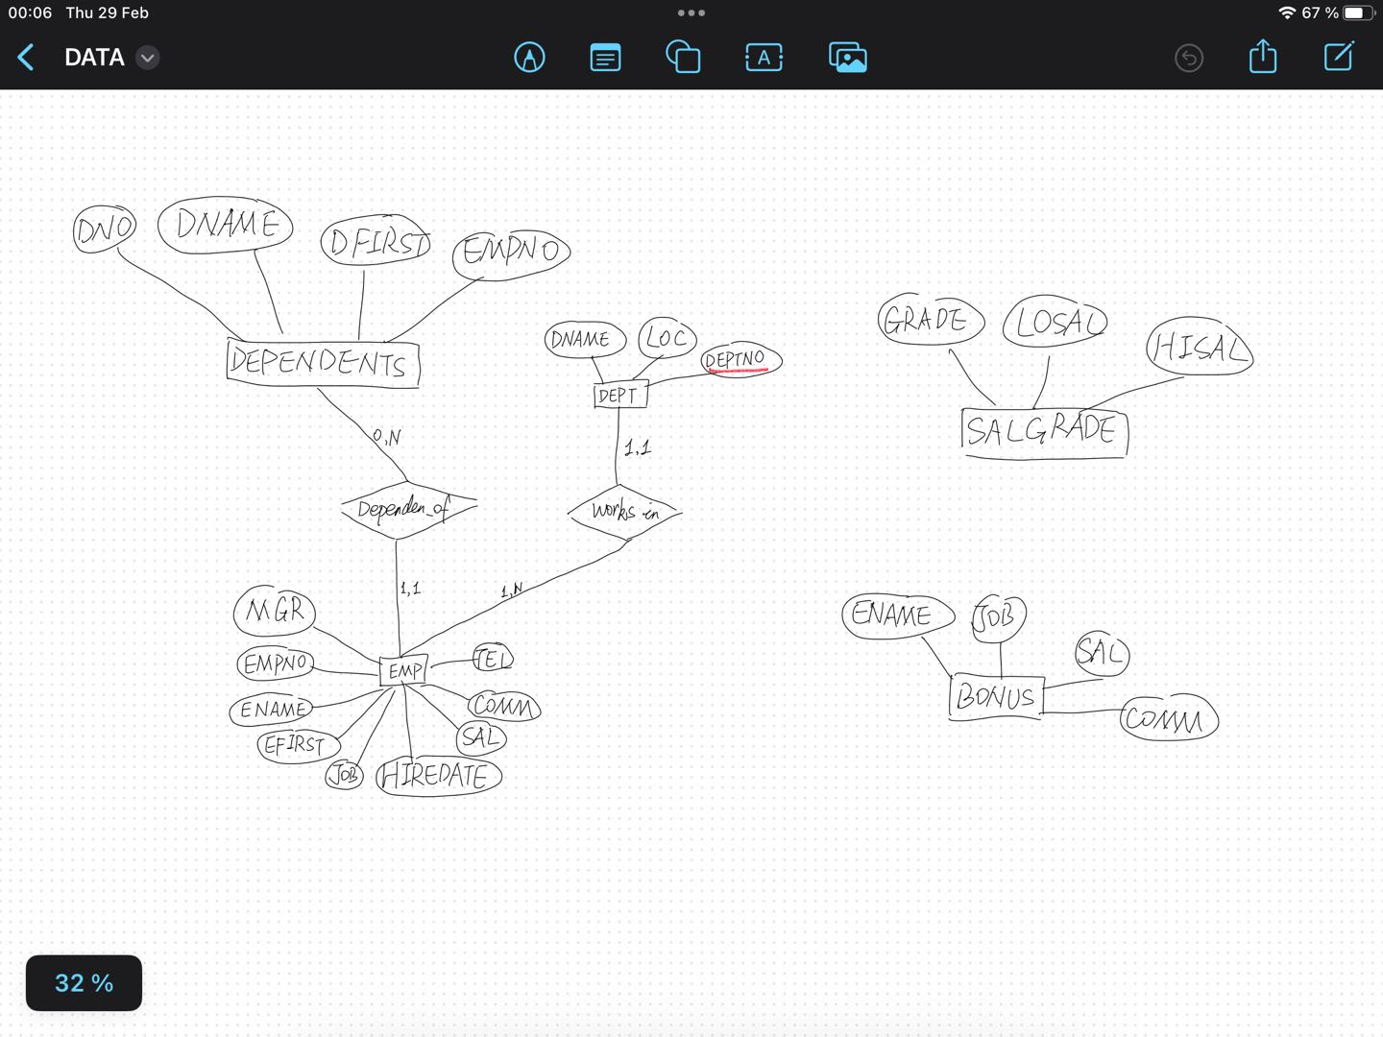

### **3. First integrity Constraint:**

### **4. Second integrity Constraint**

### **5. Third integrity Constraint on Delete**

**1) remove the referential constraint fk_ depenent_emp**

**2) delete an employee and remove all his dependents on the same time.**

**ON DELETE CASCADE is an option used when setting foreign key constraints in the database. It defines that when a record in the referenced table (parent table) is deleted, for the table (child table) containing the referenced key (foreign key) The behavior of how associated records should be processed.**

### **6. Explain Errors for Integrity Constraint**

**If run the code directly, we will find that due to the existence of null information, then need to do the following:**

**ALTER COLUMN MGR DROP NOT NULL is used to modify column attributes in database tables. This statement is used to remove the NOT NULL constraint on the MGR column in the EMP table. In SQL, the NOT NULL constraint is used to ensure that a column cannot contain null values (NULL), that is, the column must have a value in each row.**

**Then run the before code again:**

**salgrade->view data check results:**

### **7. Define a sequence**

### **8. Use Sequence:**

## **Exercise 2: DML queries Answer the following queries using SQL.**

### **List the content of all tables to see the attributes names.**

### **Select employees whose commission is higher than their salary.**

### **Select employees earning between 1200 and 2400 (earning is sal + commision)**

### **Select employees who are CLERK or ANALYST**

### **Select employees whose name begins by M.**

### **Select employees whose name includes a L in second position.**

文本, 表格

### **Select employees who are MANAGER or CLERK in the department 10 and whose salary is greater than 1500.**

### **Select employees whose commission is NULL**

### **Select employees by ascending order (by hiredate)**

表格

### **Select employees ordered by job, and for each job, by decreasing salary**

### **Select departments without employees**

### **List employees indicating for each the name of his/her manager**

### **List employees earning more than JONES**

### **List employees displaying in the same column salary and commission**

**Note: The COALESCE function requires all parameters to be of the same type**

### **List department numbers which are both in table EMP and in table DEPT**

### **List employees working in CHICAGO and having the same job than JONES**

### **List employees who don't work in the same department than their manager**

### **List employees working in a department having at least one CLERK**

表格

### **List employees of department 10 having the same job than someone from the department SALES**

### **List employees having the same job than JONES or a salary greater than FORD's salary**

图形用户界面, 文本

### **List employees having a salary greater than all employees of department 20**

表格

## **Exercice 3: Join Table**

### **Create a Table for employee’s Projects:**

### **Create the Join Table:**

**Create table project_emp:**

**Insert project data into the project table:**

**Insert project data into the project_emp table:**

### **List all employees (by empno) who work on all projects?**

### **Options on View creation:**

**“CREATE VIEW” statement creates a view named sales_staff, Select the data from the three fields empno, ename and deptno from the emp table, which only contains information about employees with department number 10.**

**“WITH CHECK OPTION” ensures that all data modifications through the view (including insert and update operations) will comply with the “WHERE “condition in the view definition: all insert or update operations through the sales_staff view must ensure that deptno remains 10.**

### **View Creation:**

**Insert a new record with deptno 10 into the sales_staff view. Insert operations are allowed.**

**Insert a record with deptno 30 into the sales_staff view. This violates “deptno=10” as well as “WITH CHECK OPTION” . Therefore, this insert operation is rejected.**

### **Division Query:**

### **Analyze:**

# **Lab 2**